Cloud Computing Lab Record

1934019 KISHORE S 1934024 NAREN KARTHIK
1934046 SREEKANTH

S.no | Index
1 | Installing Oracle VirtualBox
2 | Running a C program on Virtual Machine
3 | Communication Between Host and Virtual Machine
4 | VM to VM Connection
5 | Exporting VirtualBox VM
6 | Importing VirtualBox VM
7 | Create VM on Azure
8 | Create WebApp on Azure
9 | Creating a shared folder
10 | Creating a Docker Container
11 | Entering into Container making Logs of the activities
12 | Installing Kubernetes
13 | Creating a GRPC server-client program and Dockerizing it
14 | Containerizing the GRPC server-client program using Kubernetes

Exercise 1 Installing Oracle VirtualBox

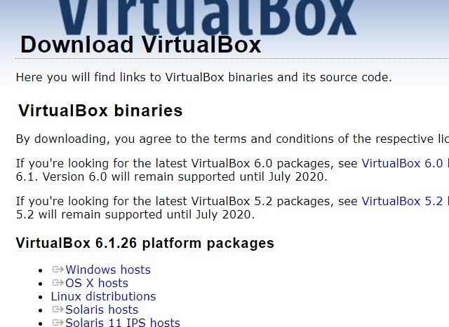
- Go to https://www.virtualbox.org/wiki/Downloads to download Oracle virtual box.
Select your OS

- Run the file
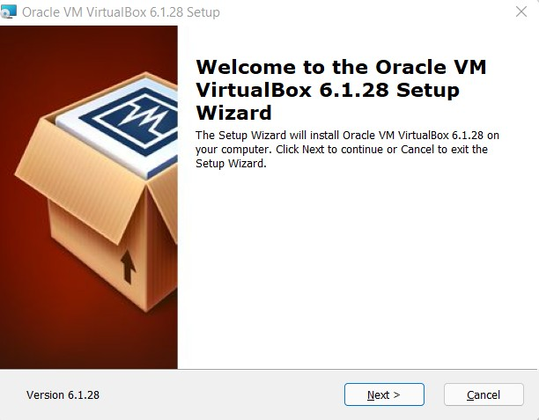
- Click Next

- Leave the default settings and click next to install

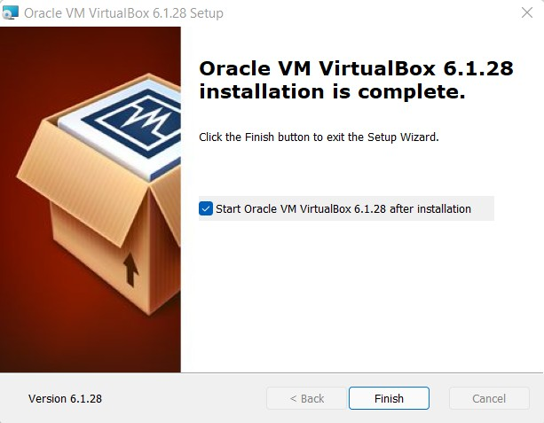

Exercise 2 Running a C program on Virtual Machine Linux
- Open text editor in Ubuntu VM.
- Write the helloworld.c Program

#include <stdio.h> void main()
{
printf("Hello World!");
}
- Save the file.
- Compile the file using “gcc -o HelloWorld HelloWorld.c”
- To run the file Type “./HelloWorld”
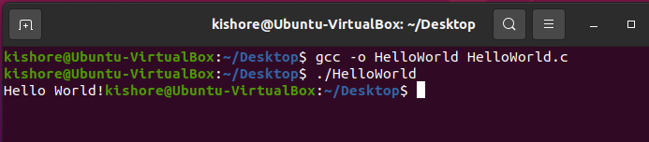

Windows

- Download MinGW GCC Compiler from https://sourceforge.net/projects/mingw/
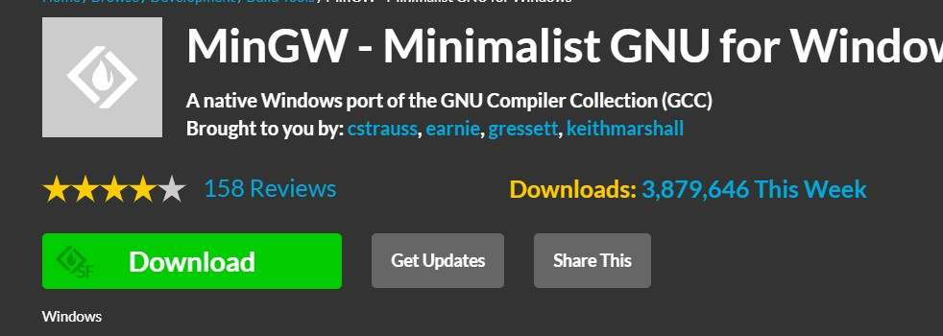
- Install C compiler from MinGW

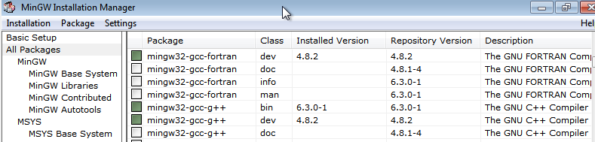
- In a Text Editor Write the same HelloWorld.c Program

- In Command Prompt type “gcc -o HelloWorld HelloWorld.c” to compile the program
- To run the program type “HelloWorld” in Command prompt
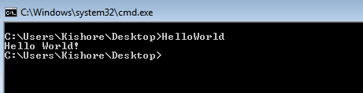

Exercise 3 Communication Between Host and Virtual Machine

- Change the adapter Settings to Host-only Adapter
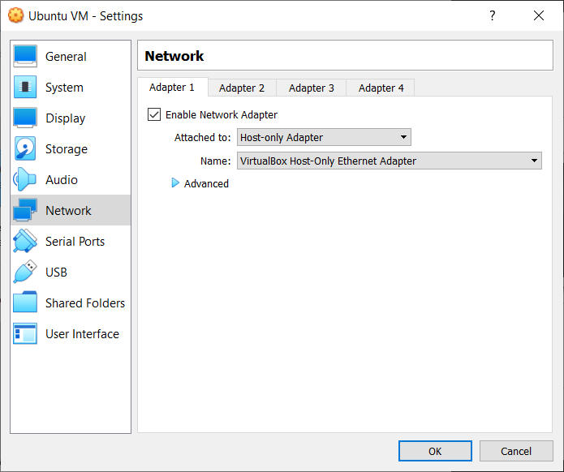

- Ping the Guest VM from the host
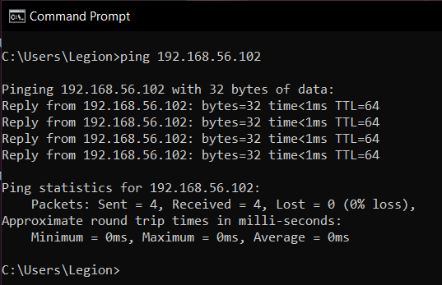

- Install XAMPP and change the required files
- Start XAMPP and Create a Database and a Table

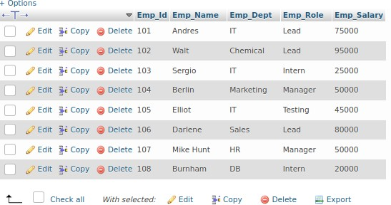

- Create a new user with IP as % or the IP of guest OS found using ifconfig.

IP
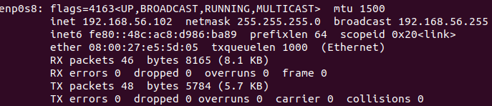

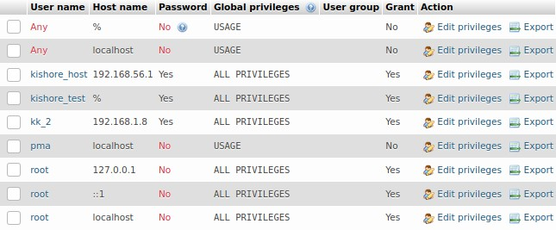
User

- Download the MySQL-connector jar file and add it to the project path in Host.

- Write a Java program to access the database in Guest OS. import java.sql.Connection;
import java.sql.DriverManager; import java.sql.ResultSet; import java.sql.SQLException; import java.sql.Statement;

public class HostVMconnection {
static final String JDBC_DRIVER = "com.mysql.cj.jdbc.Driver";
static final String DB_URL = "jdbc:mysql://192.168.56.102:3306/employee"; static final String USER = "kishore_test";
static final String PASSWORD = "password";

public static void main(String[] args) { Connection conn = null; Statement stmt = null;
try {

PASSWORD);
Class.forName(JDBC_DRIVER); System.out.println("Connecting to a selected database..."); conn = DriverManager.getConnection(DB_URL, USER,

System.out.println("Connected database successfully...");

System.out.println("Connecting statement"); stmt = conn.createStatement();
System.out.println("Id\tName\tDept\tRole\tSalary"); String sql = "SELECT
Emp_Id,Emp_Name,Emp_Dept,Emp_Role,Emp_Salary FROM Employee"; ResultSet rs = stmt.executeQuery(sql);
while(rs.next()) {
int id = rs.getInt("Emp_Id");
String name = rs.getString("Emp_Name"); String dept = rs.getString("Emp_Dept"); String role = rs.getString("Emp_Role");
int salary = rs.getInt("Emp_Salary");
System.out.println(id + "\t" + name + "\t" + dept + "\t" + role +
"\t" + salary);

}
rs.close();
}
catch(SQLException se) {
se.printStackTrace();
}catch(Exception e) {
e.printStackTrace();
}finally {
try {

}
}try {
if(stmt!=null)
conn.close();
}catch(SQLException se) {

if(conn!=null)
conn.close();

}catch(SQLException se) { se.printStackTrace();
}
}
}

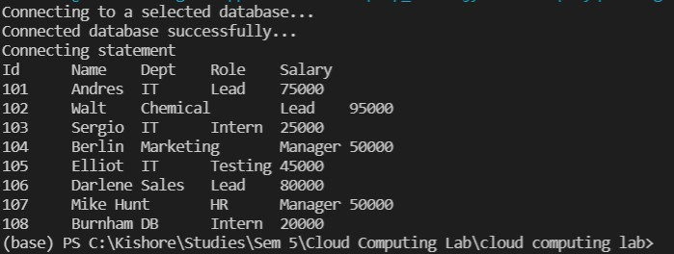
- Run the program and Verify the result

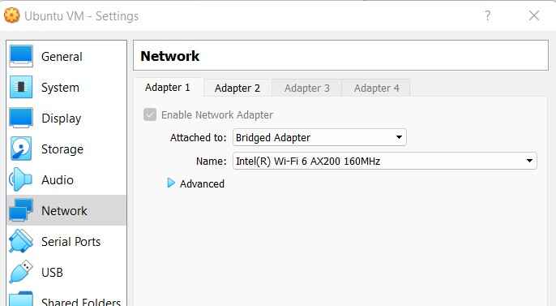

Exercise 4 VM to VM Connection

- After installing two VMs, change their network settings to BridgedAdapter
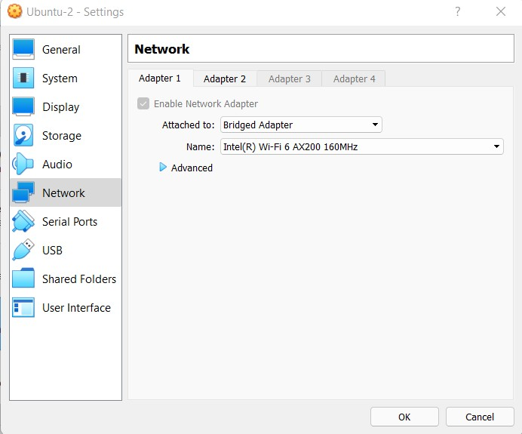

- Ping and verify both are able to communicate with each other.
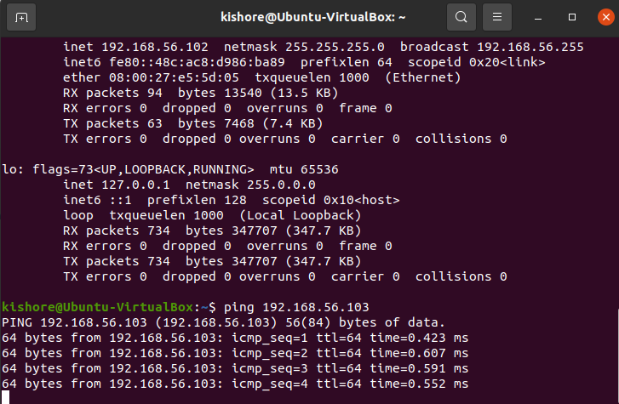
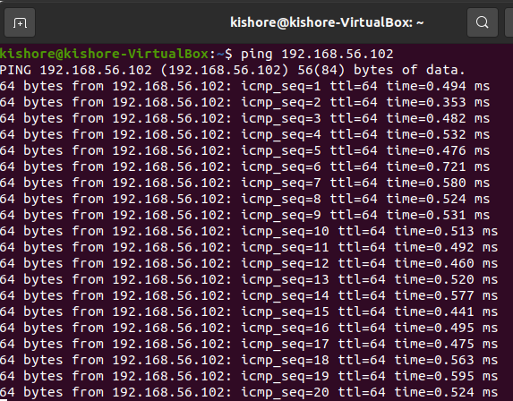

- Install Java in the VM-B (From which we are going to access the database).

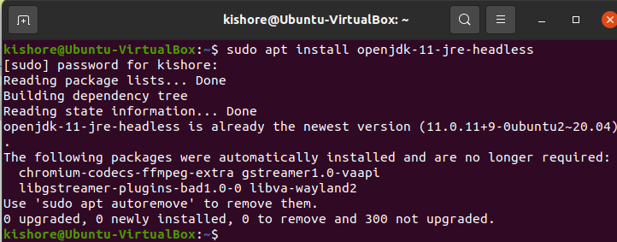
VM-B like VisualStudio Code or Eclipse
- Install a code editor/IDE in the

- Download the XAMPP package in the VM-A (Where we are going to create the Database and Table).
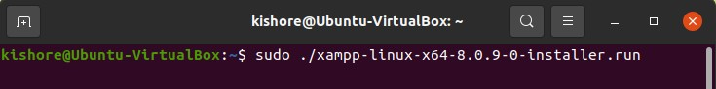

- Edit my.cnf file and start XAMPP
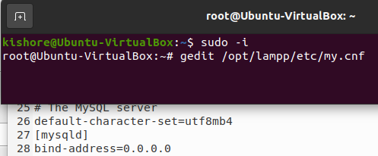

- Create a Database and Table using phpmyadmin
- Insert records into the table
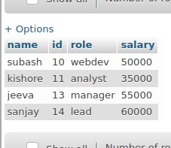

- In both the VMs change the second network adapter to Host-only-adapter
- Create a user in the PHPMyAdmin with IP either as “%” or the IP of the VM-B

- Download the MySQL-connector-java and add it to the project path where the code is present in VM-B
- Write the Java program in VM-B to access the database from VM-A import java.sql.Connection;
import java.sql.DriverManager;
import java.sql.ResultSet; import java.sql.SQLException; import java.sql.Statement; public class vm_to_vm {
static final String JDBC_DRIVER = "com.mysql.cj.jdbc.Driver";
static final String DB_URL = "jdbc:mysql://192.168.56.102:3306/Employee-1"; static final String USER = "kishore";
static final String PASSWORD = "password"; public static void main(String[] args) {
Connection conn = null; Statement stmt = null; try {

PASSWORD);
Class.forName(JDBC_DRIVER); System.out.println("Connecting to a selected database..."); conn = DriverManager.getConnection(DB_URL, USER,
System.out.println("Connected database successfully..."); System.out.println("Connecting statement");
stmt = conn.createStatement();

String sql = "SELECT id,name,role,salary FROM emp"; ResultSet rs = stmt.executeQuery(sql);

while(rs.next()) {
int id = rs.getInt("id");
String name = rs.getString("name"); String role = rs.getString("role");
int salary = rs.getInt("salary"); System.out.println("ID: "+id); System.out.println("NAME: "+name); System.out.println("SALARY:"+role); System.out.println("SALARY:"+salary);
}
rs.close();
}
catch(SQLException se) {
se.printStackTrace();
}catch(Exception e) {
e.printStackTrace();
}finally {
try {

}
}try {
if(stmt!=null)
conn.close();
}catch(SQLException se) {

if(conn!=null)
conn.close();

}catch(SQLException se) { se.printStackTrace();
}
}
}

- Run the program to see the results
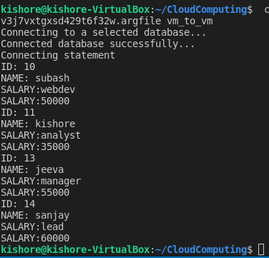

Exercise 5 Exporting VirtualBox VM

  - Open VirtualBox
  - Click on File --> Export Appliance
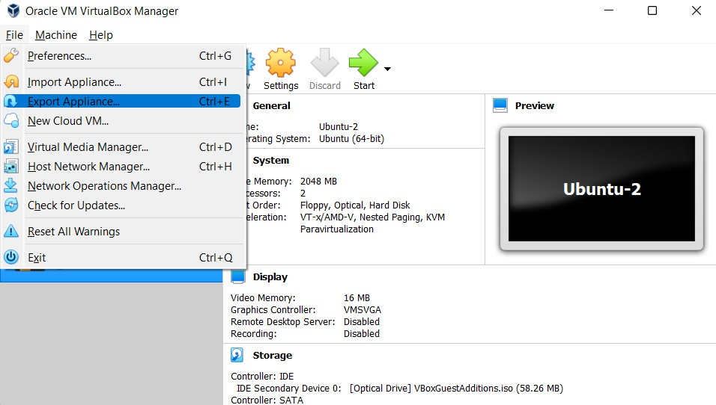

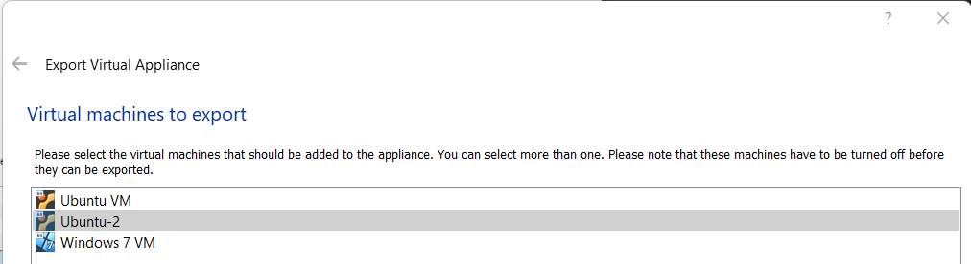
  - Select the VM you want to export

  - Select Location to store the exported VM and click Next
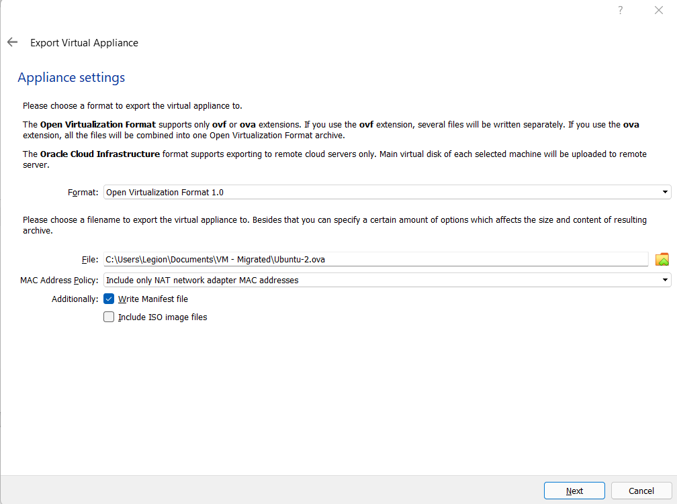

  - Add Description if wanted and click export to store the file in the location specified
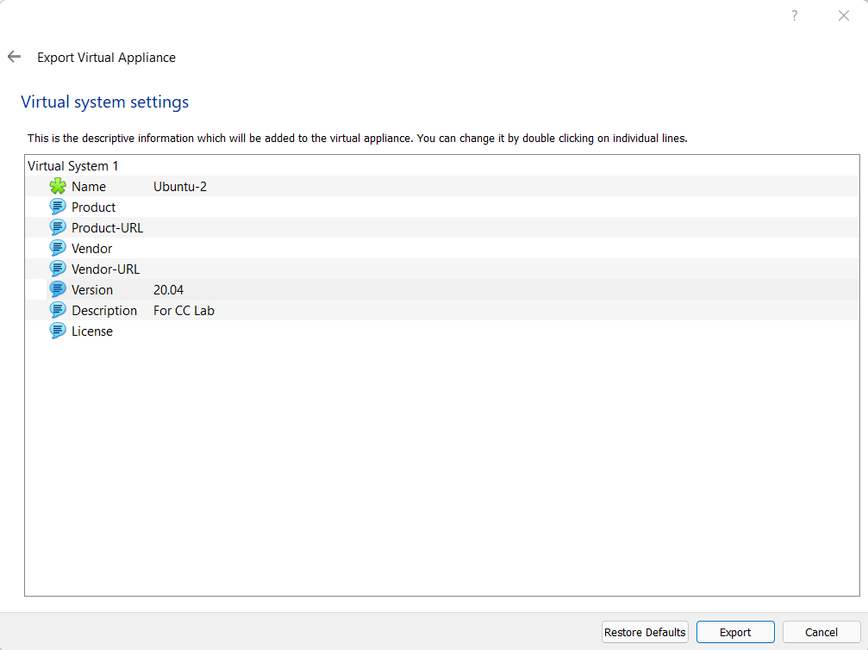
  - Wait for the process to complete
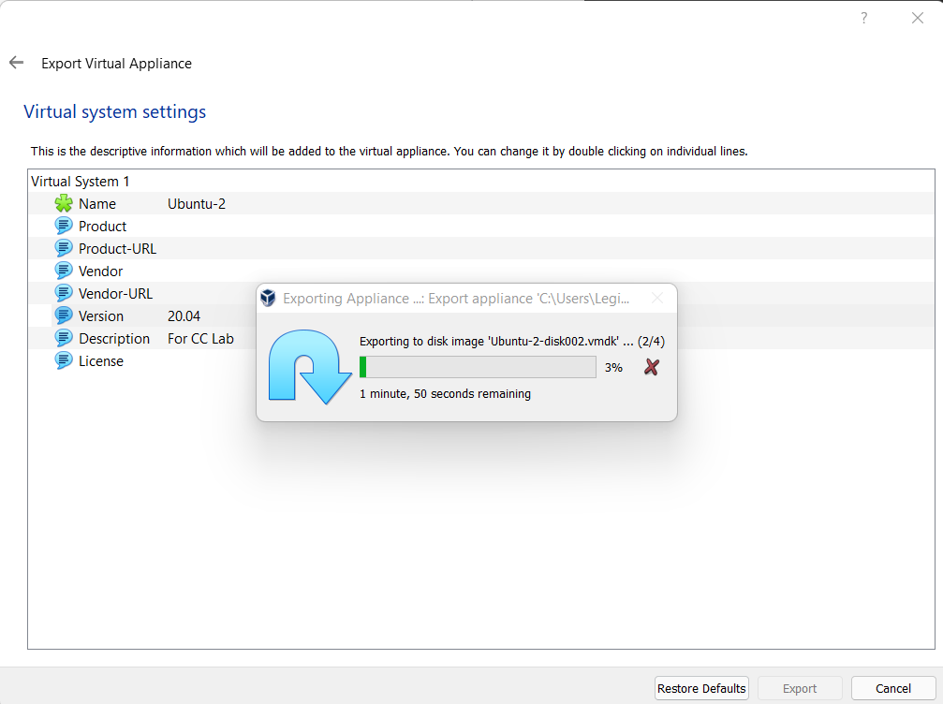

  - Check the Location to see the exported .ova file.
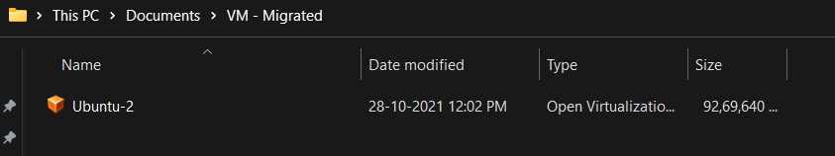

Exercise 6 Importing VirtualBox VM

- Start VirtualBox
- Click File --> Import Appliance
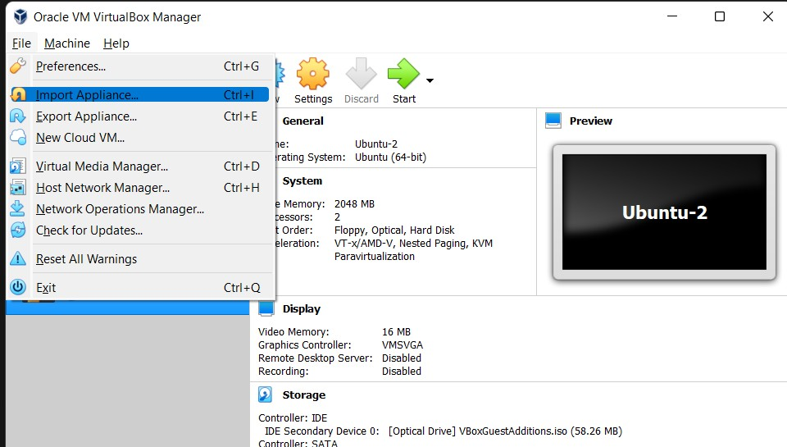

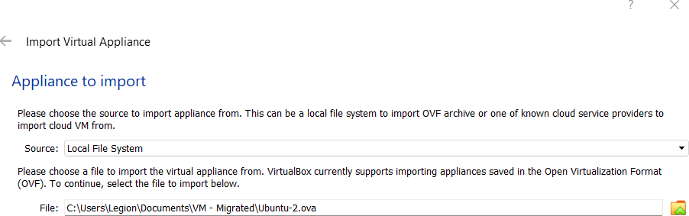
- Select the OVA file and click next

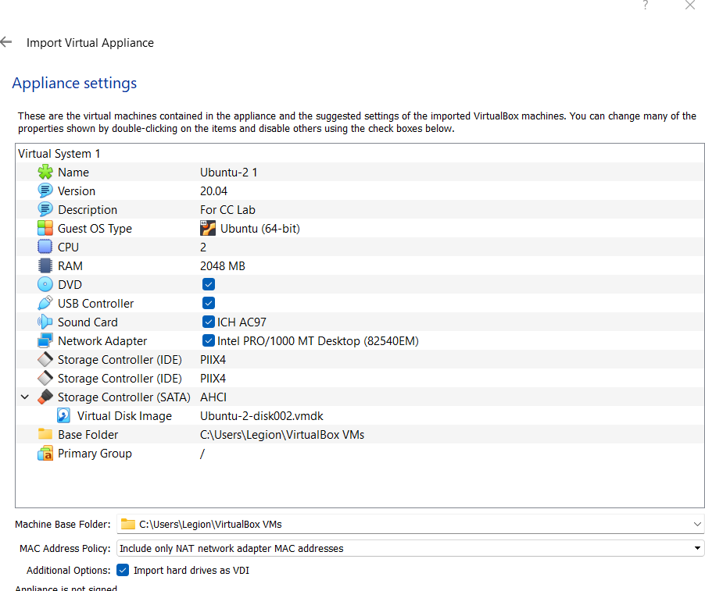
- Leave the default settings and Click import

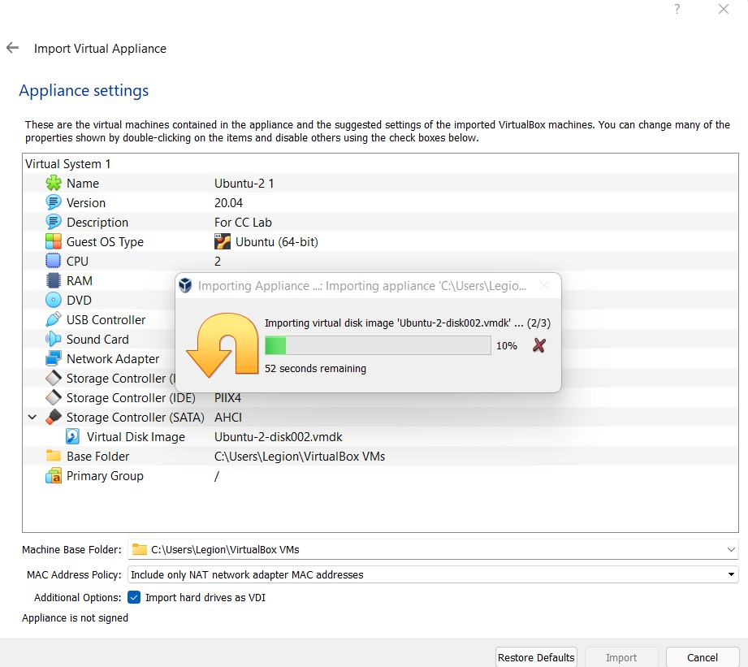
- Wait for the import to finish

- The machine
will be seen on the
VirtualBox homepage
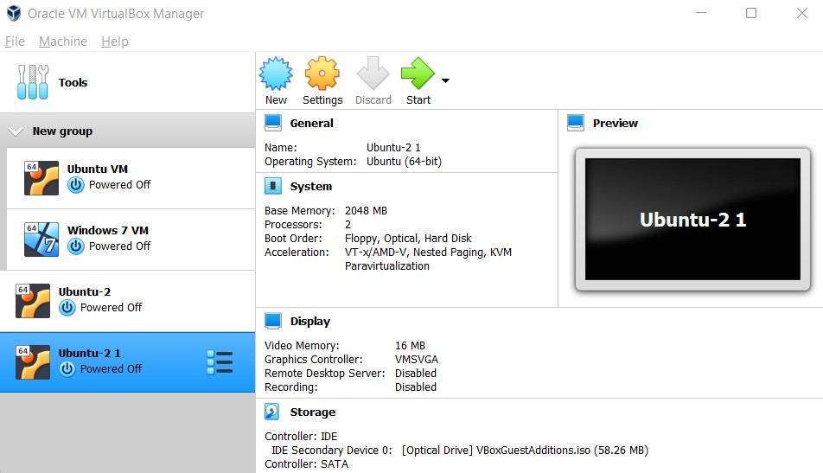

Exercise 7 Creating a shared folder

- Configuring the network settings

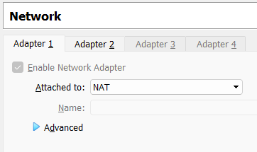
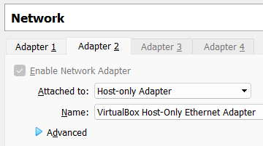

- Install Guest addition images
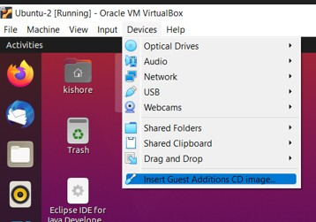

- Go to shared folder settings
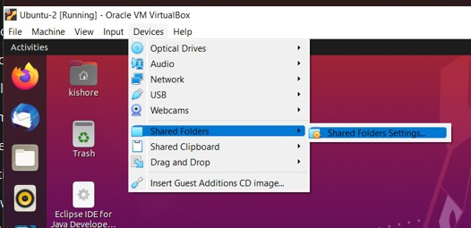

- Click on Add new Shared folder
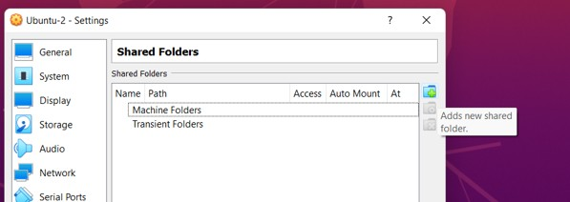

- Select Folder Path and give it a name. You can also make it read-only, auto-mount and permanent by checking the respective boxes

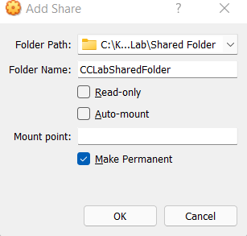

- Permanent folder will be under machine folders, if not under Transient folder

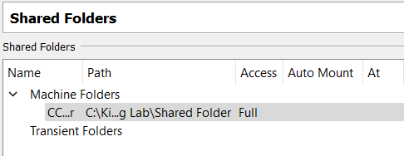

Exercise 8 Creating a VM on Azure

- Click on the three horizontal bars to see the create resource icon.

- Click on create resource

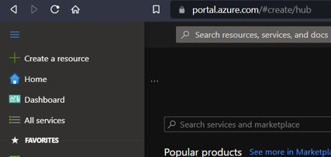

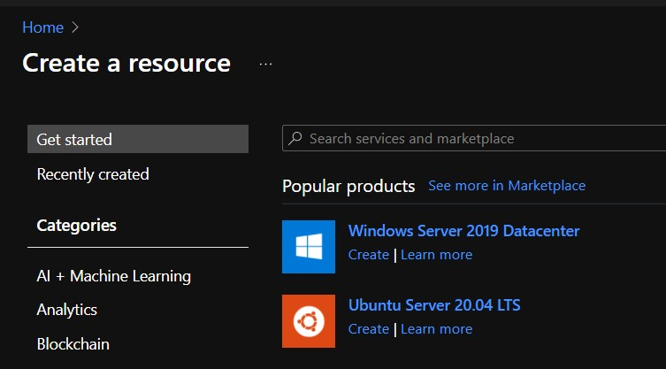
- Select windows server

- Fill out the details

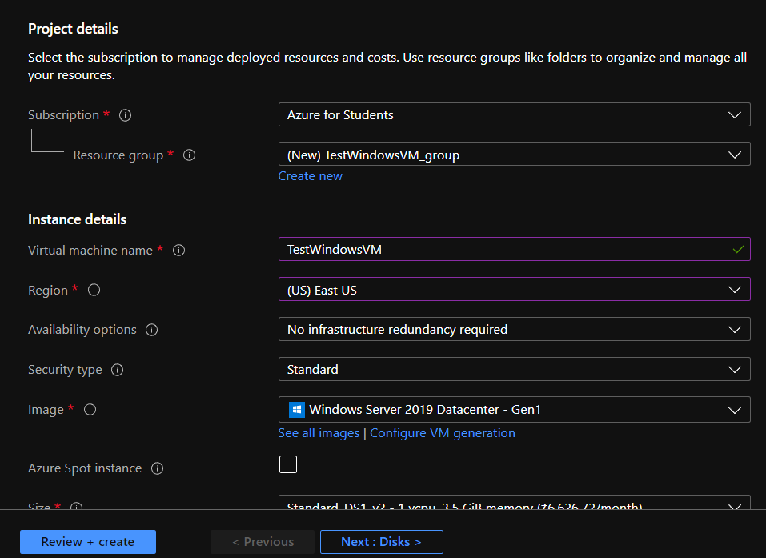

- Click review and create

- Click on create
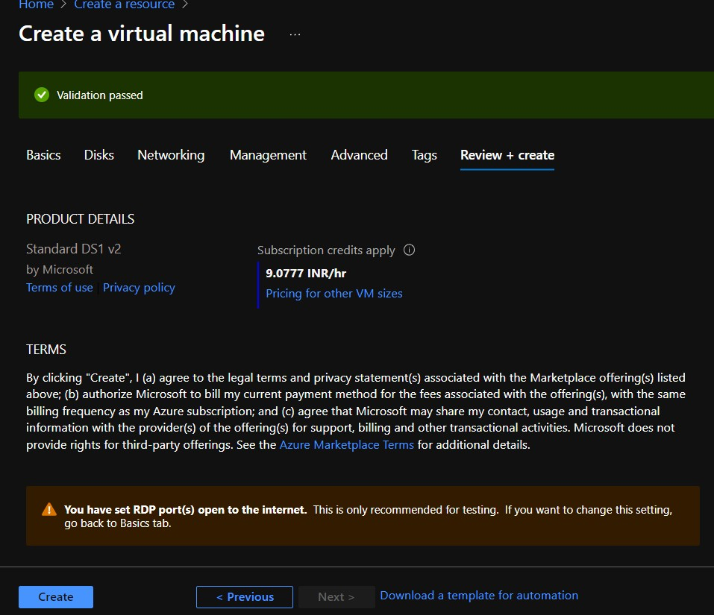

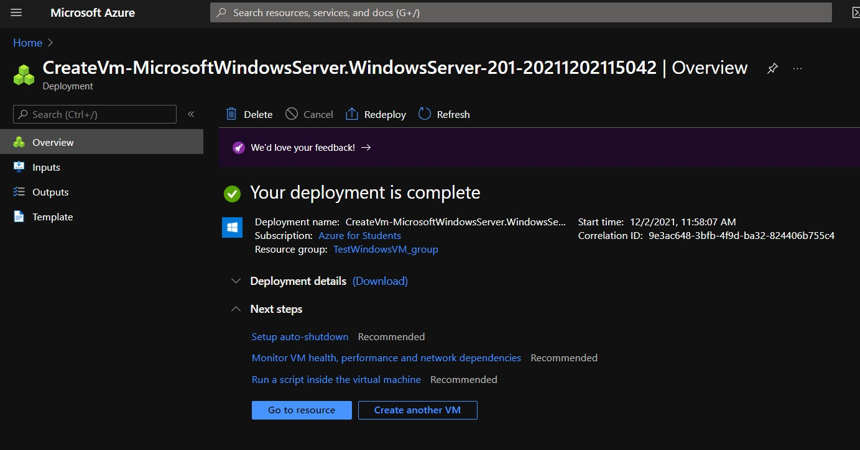
- Click on Go to resource once deployed

- Click connect to remotely connect using SSH or RDP (If needed)
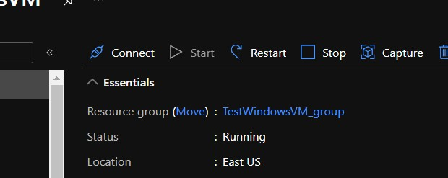

Exercise 9 Creating a static web app in Azure Portal

- Click on Create Resource
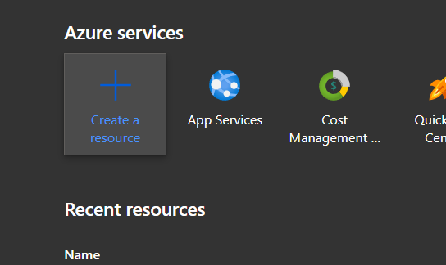

- Search for Static Web App
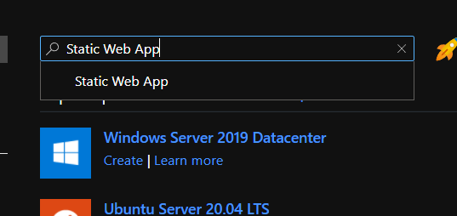

- Select Static web app

- Select Create
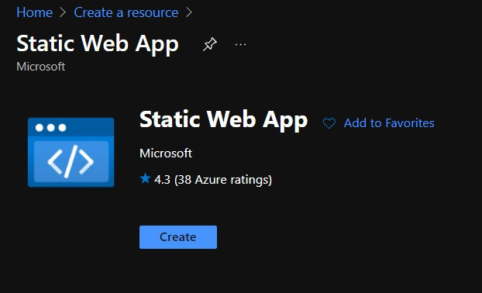

- Fill out the details
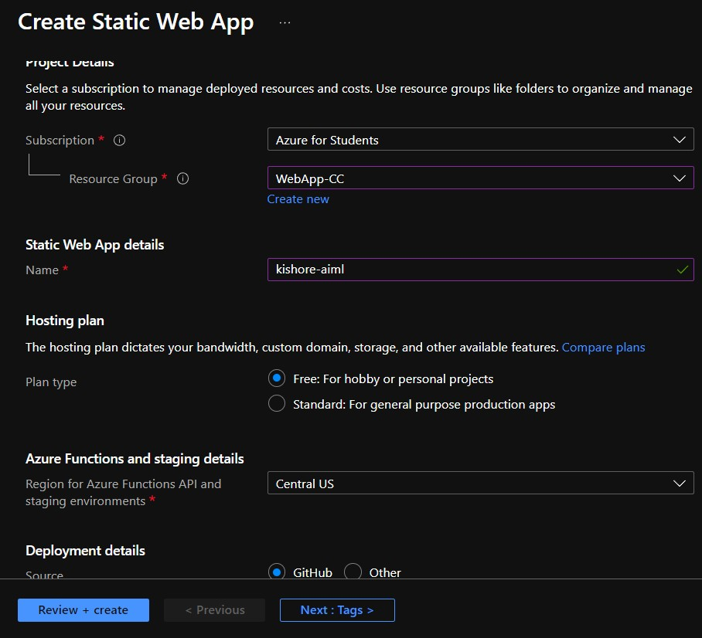

- Sign in via GitHub

- Select organization, Repository and Branch where the HTML file is located
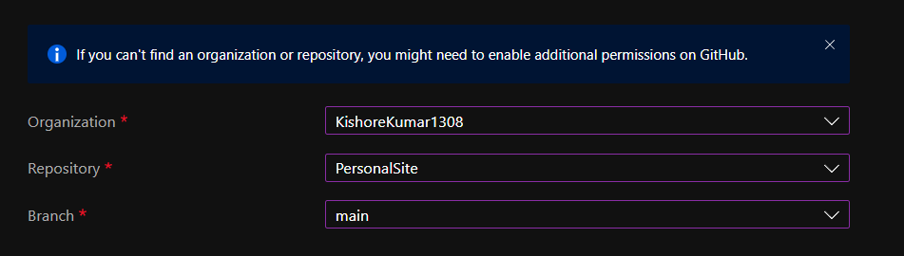

- The GitHub repo should look like this
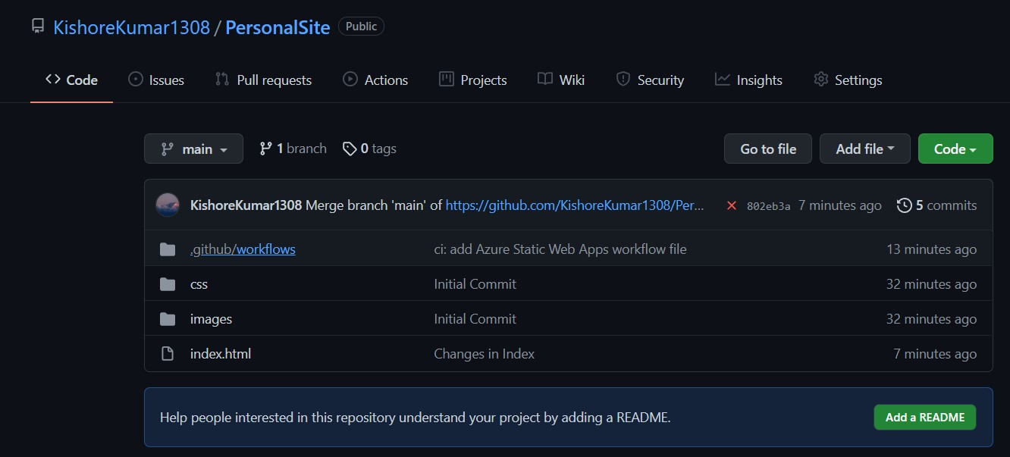

- Fill in the following Build Details
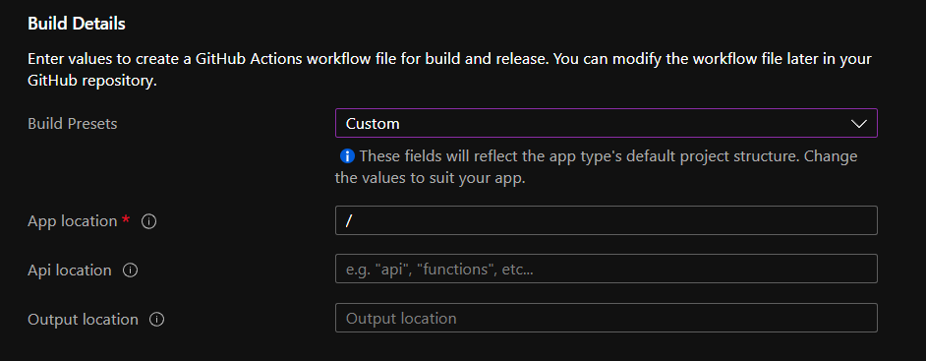

- Click on Review + Create

- Click on Create

- Click go to resource

- The URL for the site will be available
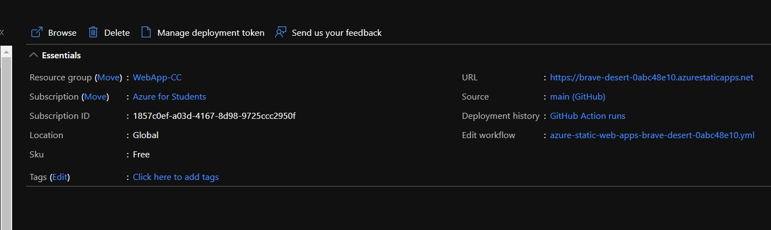

- Click on the URL to see if it is working
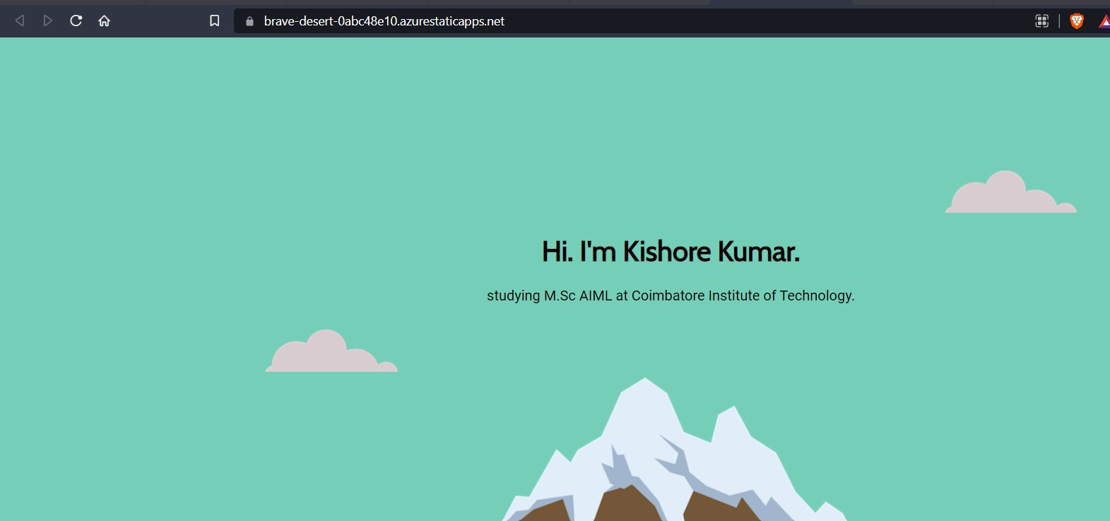

- This is the URL for the Static Web Page created by me: https://brave-desert-0abc48e10.azurestaticapps.net/

Exercise 10 Creating a Docker Container

  - Install a Linux OS in VirtualBox.
  - Install net-tools and ssh.

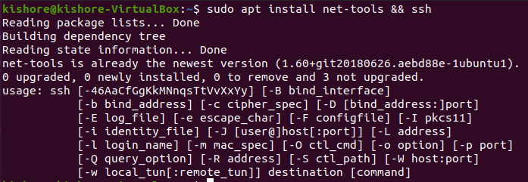
  - Find IP of the Linux guest machine.

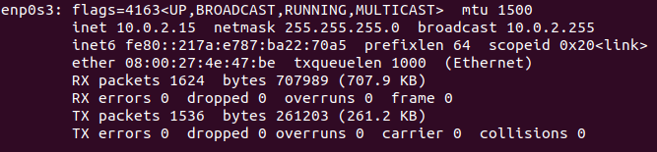
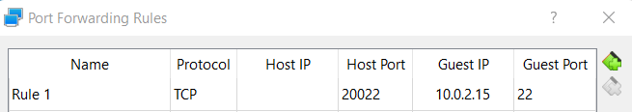
  - In the VirtualBox Setting for this OS, Go to Network -> Advanced -> Port Forwarding, Give Host port as 20022, Guest IP found from ifconfig, and Guest port as 22. Save the changes.

  - In the host machine, Open Command prompt. Type ssh
Linux-username@127.0.0.1 -p 20022. Grant access if asked and type the guest Linux OS password.

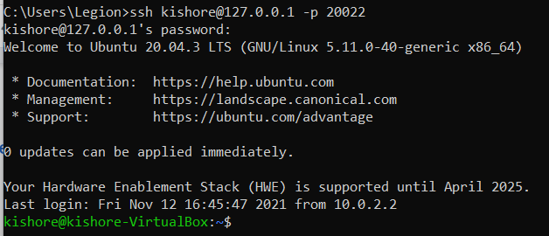

  - Create a simple HelloWorld program in the language of your choice. (GoLang here)

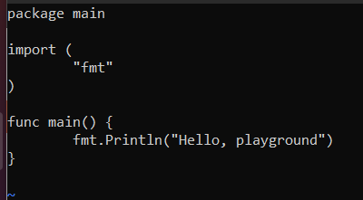

  - Build the program and verify the output

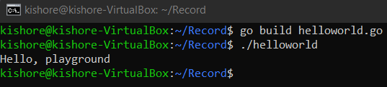

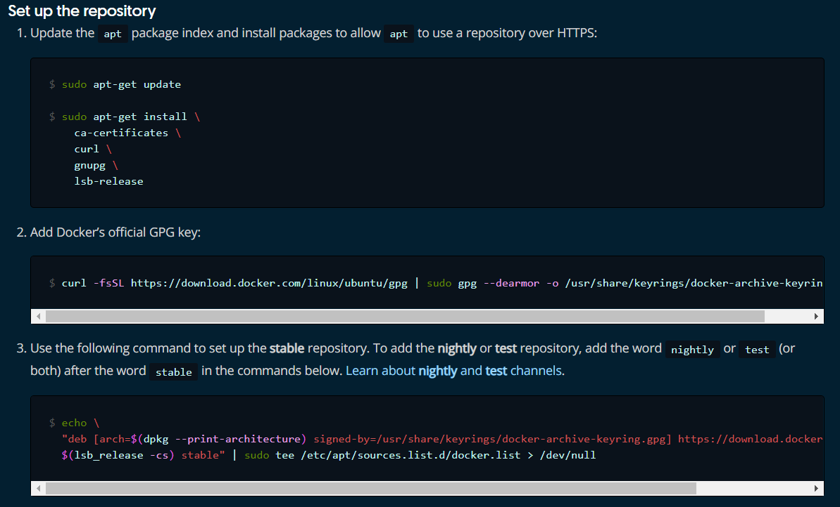
  - Go to https://docs.docker.com/engine/install/ubuntu/ and add the docker repository to the Ubuntu OS.

  - Install Docker

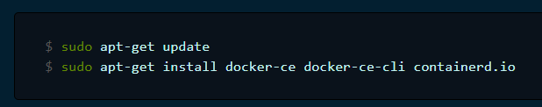

  - In Linux create a “Dockerfile” with the following contents

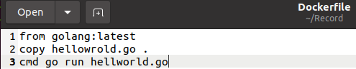

  - To build the container type “sudo docker build -t test:1 .”
  - To view the image do “sudo docker images”
  - To run the image do “sudo docker run test:1”

Exercise 11 Entering into Container making Logs of the activities

- Modify the helloworld program to run for 5 minutes

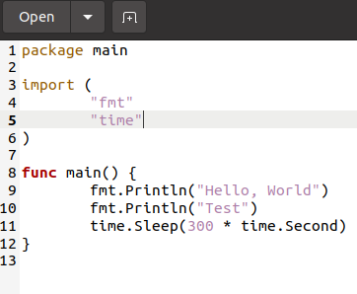

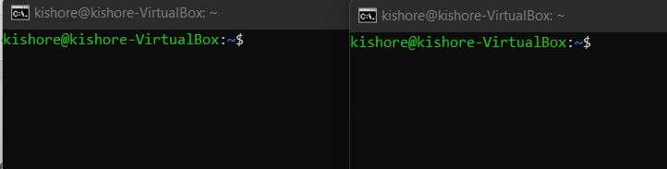
- Open two SSH terminals from host

- Build the modified hellworld program as a docker container and run it in SSH one terminal.
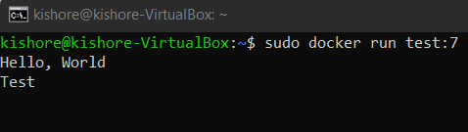

- Enter into the running container from the other terminal using the following commands
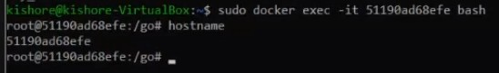

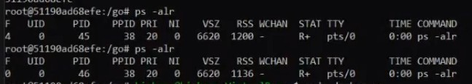
- To view the process running inside the container do

- Add log comments to the file to check for any runtime errors

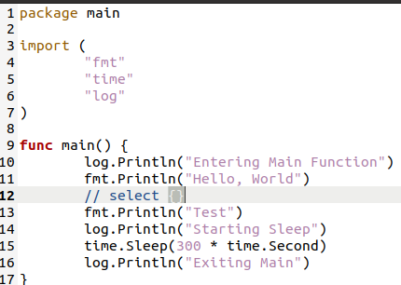

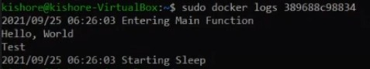
- To view, the log messages do the following

- Instead of using the entire golang, we can use only the required packages using alpine

Exercise 12 Installing Kubernetes

- Go to
https://kubernetes.io/docs/setup/production-environment/tools/kubeadm/install-ku beadm/
- Install the prerequisites as mentioned in the website

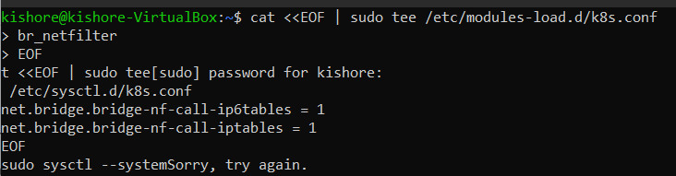

- To install kubeadm, kubectl, kubelet type the commands as mentioned in the website
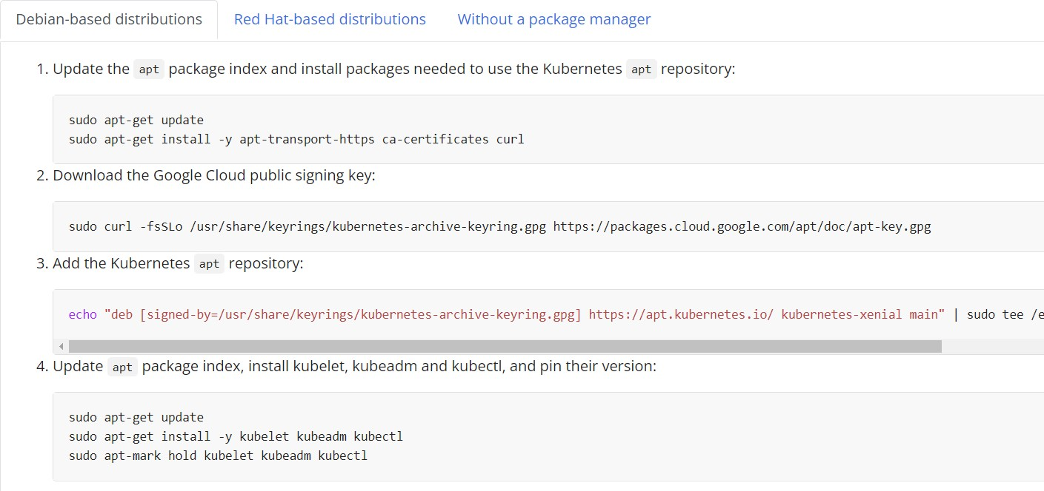

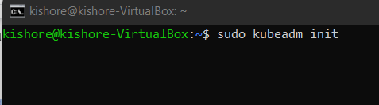
- To initialize kubeadm, use sudo kubeadm init.

- Turn off swap using swap -a
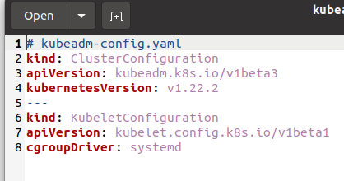
- Create a kube configuration yaml file

- Use “kubectl get pods -n kube-system” to see the pods.
- Add Calico for Kuberentes from https://docs.projectcalico.org/getting-started/kubernetes/quickstart
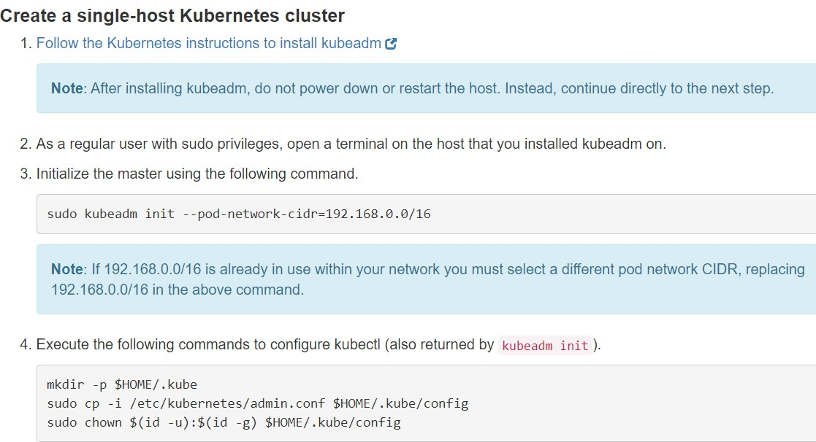

- Create a helloworld kubernetes file by following the steps in the GitHub page https://github.com/paulbouwer/hello-kubernetes

Exercise 13 Creating a GRPC server-client program and Dockerizing it

- Install grpc plugins for golang

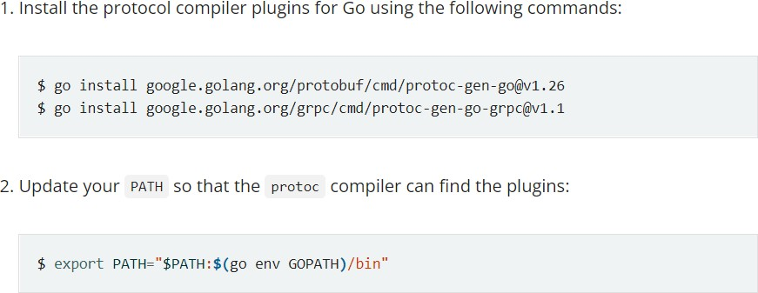
- Get the example code

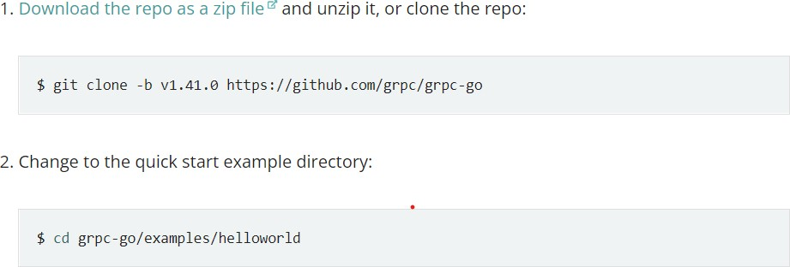

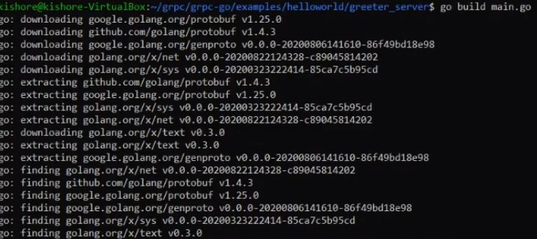
- Build the main.go file
- Create a docker file for the grpc server and client program
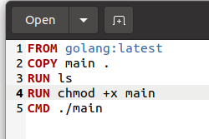

- Build both the docker files
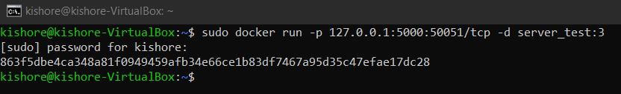
- Change port as 50051 in the greeter go file and enable port forwarding in server using

- Change the listening port in client as 5000 and run the main.go file

Exercise 14 Containerizing the GRPC server-client program using Kubernetes

- Create a Kubernetes deployment YAML file from https://kubernetes.io/docs/concepts/workloads/controllers/deployment/
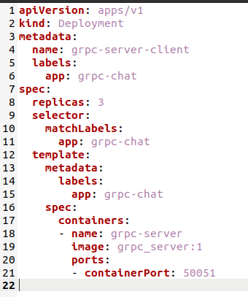
- Make the necessary changes in the file as below
- Create the deployment using
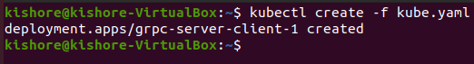
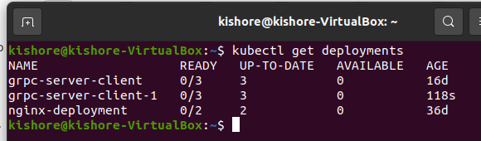
- See the deployments using kubectl get deployments

- Create service.yaml file from https://kubernetes.io/docs/concepts/services-networking/service/
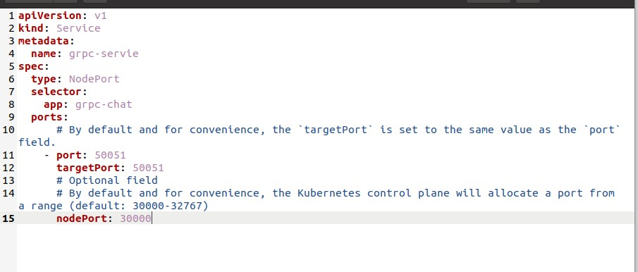
- Deploy the services
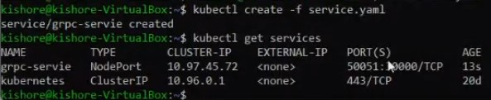

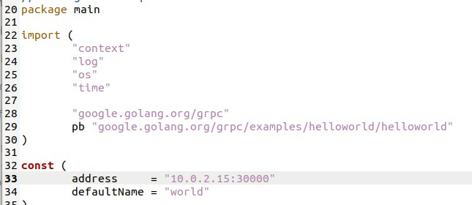
- Change the IP in the greeter_client file and run the program to see the results

